Evolution of matter complexity is „pyramidal“


introduction
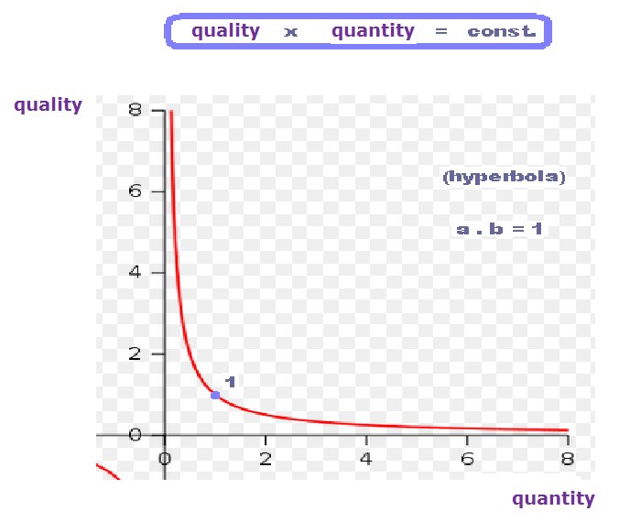
quality x quantity = const. (hyperbola) ; a . b = 1

Quality multiplied quantity is constant. In other words : more superior things occur in less amount ... and vice versa. It is so called pyramidal principle. Or in other words – if state of the artefact (state of element/elements) is simplier then such states will be presented in higher volume.
Complexity multiplied quantity is constant. In other words: more complex artefact – less in volume ... and vice versa.This is pyramidal principle.

Pyramidal principle here means that forms of mass structures, shapes- states which were „frozen“ after their origin after the Big Bang in succession from simple ones to more complex are not destroyed when time is running forward. They are not even modified but stay still the same. (Photon is already 14 billions of years „the same artefact“, the same „clone“ like electron, proton, sodium,gold, sulphuric acid, peniciline .... as far as DNA and life was originated). It is my intention to call any matter formation i.e elementary particle, atom, molekule,substance etc. as far as protein and DNA as a „clone“. As though universe would start to run a stream of evolutionary „offers“, flow in the frame of unbelievable spreading performance. And from this pallet - from this spreading cauliflower – „at the same time“ always one of the state was frozen and stayed unchanged forewer. Universe always „had choose“ just at the moment certain form for corresponding particle, atom, molecule, substance which is unchangeable and observed until present in the same way. (Parameters are chosen and never will be changed, that’s the point). For better imagination: imagine development/ calculation of the number „pi“ and succession of moments in to which certain values of this number were chosen and „frozen.“ They became clones....//
Each of mass „product“ of the universe (simple one), that will „jump out“ from space-time foam as the already „frozen wave-agglomeration“ – clone with given structure – is and will be in such form staying forewer in unchangeable position. All such parameters as (spin, charge, flavour, strangeness, mass – even mass is just property of the matter but nothing else!!, baryonic and leptonic number, life time of the particle etc.etc., all of this is already unchangeable „product“ of the universe.
This finding, this fact of the „already made clones forewer“ doesn’t necessary mean lack of their next mutual interactions in the future in the course of growing up their complexity. It must be emphasized only, that amount of those ones that are so called basic ones jumped out of the space-time foam is not too much wide. They are as follows: photon,electron,neutrino,graviton, quark. ....This doesn’t mean that these wave-agglomerations are not developed further in the sense of their next evolution according to arrow of growing up of complexity giving birth to atoms,molecules, substances etc...
Of course, it doesn’t mean that more complex structures which have arisen from the simplier ones cannot again be „decomposed“ backwards. Let’s see chemistry, biology.... etc. Next new and more complex structures in succession of their evolution are just „conglomerates – composites“ going into chemistry, biology where they are just modified...; It’s entirely simple modern image „to assemble“more complex matter by mechanism of mutual „stitch knitting“ of the basic wave-agglomerations composed of dimensions of the two basic quantities.
Nature always permits divisions of the more complex structures only to the „same“ wave-agglomerations. If we would like to destroy quarks and electrons then there is barrier behind which the next destroying processes are prohibited. More honestly, I do not know it. Perhaps struggling for the next disintegration of the matter in accelerators will always finish just at the shatters – jets of the matter. Thus – here is really necessary a need to be aware of and understand to that all barionic and other matter as well are composed of the „basic“ wave-agglomerations which are the same during whole history of the universe.
The point is that universe already never ever will produce different kind of these basic wave-agglomerations in question that those which are already done. What is done is done. Of course, the question why universe produced right those of the basic wave-agglomerations from space-time foam that are known to us is inexplicable. Perhaps the very first ones which are only three – (photon, electron and quark...) „jumped out“ as a clone – wave-agglomeration accidentally and formed themselves into shape-structure of that w a v e – a g g l o m e r a t i o n. Together and at the same time with this process there had to be also the law – rule arosen.
Next evolution of the next wave-agglomerations could not be already random. Every next „clone“ – form of wave-agglomeration had to be subordinated to the last ones and also to the laws of the last ones. There‘s happening logically interesting, non-random succession of realization of new particles, atoms from them, molecules and substances ... succession that already by principle cannot be perfunctorily random but strongly depending on already and previously achieved states.
The same conclusion we can say about succession of aborning laws. Those ones also cannot be chosen randomly from „chaos of all of possibilities“. All SUCCESSIVE states are directed by PRECEDENT ones .... Evolution of both successions is from this point on directed by themselves. Randomness gone, randomness performed itself only in very beginning after the Big-Bang during creation of the very first three elementry particles. (They could be of any kind). Someone can object to that the Universe had „created“ all existing laws at once but this is not true. For example there did not exist the law describing reaction between acids and bases after the Big-Bang and there are plenty examples like that there. Even laws-rules are born successively in time during aging of the universe as the flabelliform succession of realization of the mass structures.

After Big-Bang situation is as follows: Physical space-time 3+3 or n+n D (curved one) is nested into Euclidean geometrical plane space-time (which is uncurved) and this one can be valuated as the „grid of axes“....
( So this was my attempt of how to approach my vision ).

>*<

As warp of the next interpretation below will be „the floors“of the following pyramid:

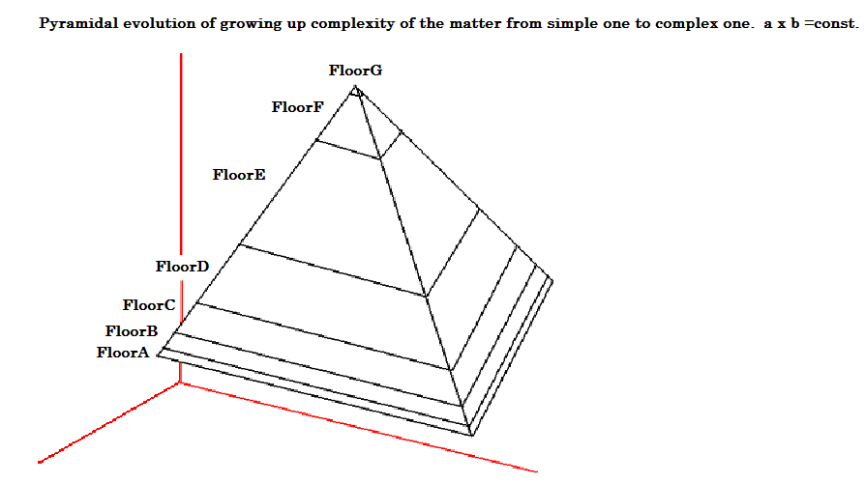
← Design - picture above here is used as a scheme for interpretation →

Floor A of the Pyramid: This is state before Big-Bang. State of the universe is such that here is plane space-time dominated, without matter, without fields. It is plane, infinite, inactive and no time is running there and no expansion is there. Obviously state of the space-time very closely to the moment of creation is 3+3 dimensional composed of the two quantities.

Floor B of the Pyramid: Big Bang is not an explosion, it is just „change of the state“ from the last one into the next one. Next state will be already „our Universe“ in which already mentioned succession of making structures of the mass elements will start to run. These structures are mutually connected. Their behaviour depends on behaviour of the others and vice versa. Simultaneously there will begin also exist succession of related physical (+chemical + biological) laws, rules and principles. etc.etc. Further – after the Big-Bang previous state of the space-time – plane one- changes itself into „curved one“. This fact is a mechanism and main reason of how and why space-time curves itself into space-time foam. This is also explanation why there is necessity to jump out of a few „clones= wave agglomerations“ of such configuration that will become matter or field by their character and manifestation staying the same forewer. But that foam of the space-time is boiling all the time until even today but on different scales. ( Currently such foam dominates on the Planck’s scales and smaller ones). Further after the Big-Bang by curving dimensions of the space-time there two different types of curvatures occured. One of them was nonlinear small type of curvature important for gravity and enormous linear curvature typical for quantum mechanics. By this curving of dimensions of the lenght and time quantities caused time itself begun to run and space itself to be expanding. Previous Pre-Big-Bang state of equilibrium point had been disturbed resulting into v < c whereas original state was c = 1/1.
Resume: After Big-Bang space-time curving begun to run and therefore also „evolution“ of the universe started up. It is beginning to be realized following phenomenons: Time is starting to run, space begins to expand, wave-agglomeration for the matter artefacts begins to run with spontaneous tendency for growing up complexity and succession of arriving of the natural laws is also coming. One of the first law, maybe the first one, is alternation of symmetry with asymmetry together with principle of the limping stairs and principle of the „hot potatoe“. Vladimir Wagner describes the floor „B“ below. Simply put, the floor „B“ includes processes as originating mass particles (and fields) + successive origin of the laws.

Floor C of Pyramid: construction of chemical elements – Mendelejev’s table
Floor D of Pyramid: inorganic chemistry, simple compounds
Floor E of Pyramid: organic chemistry and its mechanisms
Floor F of Pyramid : bioorganic polymers, proteins like structures
Floor G of Pyramid: DNA and protein collaboration, living organisms

Before I will start to describe enumerative „states of the pyramidal floors“ I must note:

Time as a quantity has got also its three dimensions i.e. ( t₁, t₂, t₃ ) in the similar way „like“ those of the quantity of lenght. These dimensions are like wire spread all over the space-time in this universe. We are those who move or shift or walk but alongside not just all three plane lenght dimensions but alongside all three plane time dimensions as well. We are those who cut intervals onto both lenght and time dimensions at the same rate. We are those who is cutting time and not vice versa that time i running toward us. NO!

Abstract from some disscussion:
Martin, try please to abandon an idea that time “is ticking“ or „taking place“ or „flows“. No,this is not the case. Time doesn’t flow forward but stands still. Time is represented in the same way like space by three infinite in lenght time dimensions, forming net and we with our movement through the space cut intervals on those time dimensions. This seems to be illussion that time is running forward independently from our movement through the three dimensional net of the lenght dimensions. It is illusion that time is running. My problem is that I can’t explain yet why >time flows into all three directions with the same rate<, thus why there are same rates of cutting intervals on time dimensions as if particle of time (three dimensional time) or grid of three time axes would twirl toward time trajectory alongside we are moving to. There is different situation in the case of the space.There three-dimensional system of the lenghts „is fixed“ toward trajectory of the mass point movement. Therefore all three components on of the lenght axes are still variable. Three-dimensional particle of the time is still twirls in order to keep intervals of time the same all the time. In the case of relativity one component of the time already dilates in direction of the movement.

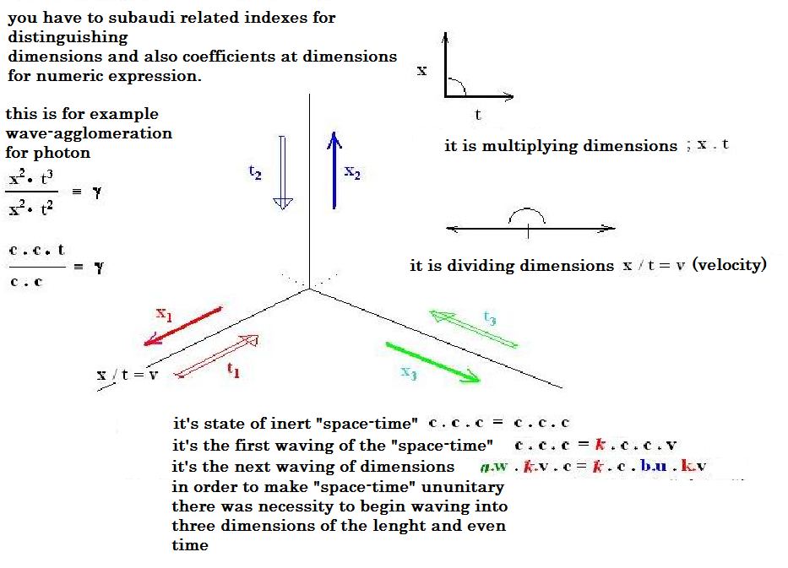

Besides of that I want to mention of the „logic of pyramidal“ evolution of the universe in more details. As you now I have aready said that quality multiplied with quantity is constant.
After the Big-Bang there was just one type of particle – „photon“. Photon’s world dominated. Then change came and part of photons was converted into quarks. Amount of photons was reduced and quarks „were born“.
Than another change came at the scene i.e new state in succession of states and another part of the photons had been changed into electrons. Then another change came i.e new state on succession of the states and part of quarks were connected together forming protons and neutrons. Possibly no free quarks left behind consequently. Then protons,neutrons and electrons begun to connect themselves together forming atoms. Hydrogen dominates in this universe About 73% of it is represented. Then helium,c. 23%, then next ones of the chemical elements appeared. Each of them which is more complex is represented in less amount in this universe. So that my conclusion is: the more complex something is, the less amount of it it‘s represented.
Of course, original product –„wave-aglomeration“: lepton, quark, boson or or whatsoever remains the same as a clone all the time during whole 14 billions of years. Its behaviour and properties never will be changed but what is changing is structure and coplexity of the mass conglomerates in that way that more and more something is higher in complexity, less and less in amount it is represented.
Then another change i.e. new state came on succession of the states and part of chemical elements bonded together forming the most simple substances (as carbon dioxide, water etc.) In such way everything is going on: First the stars of the first generation are coming to form atoms (genesis of elements), then the stars of the second generation create simpliest substances and then next stars with planetary systems already tobe formed bring more complex structures. But among the more complicated structures the most complex ones are presented in the least number. Even after 14 billions of years there is same amount of hydrogen, helium and next simple elements and substances in the universe but number of the stars producing complex matter is still decreasing.
I am aiming my interpretation toward conclusion that according to pyramidal evolution number of the stars and planets bearing complex substances is really very small. Maybe that pyramidal principle will lead to the conclusion that we – people – are the most complex form of the matter in whole universe and anywhere else matter must be simplier in structure. If science will find that the more complex matter the less it is presented in its amount then principle of pyramidal evolution will be proved. Then it will not be possible to proclaim that intelligent aliens live somewhere in the universe together and alongside with humans. Principle of pyramidal evolution would not be confirmed of validity.
Biological ageing is also governed by „global evolutional law“ that also generated itself within period of 14 billions of years. Lead, sulphur trioxide „are not ageing“ (even within period of 5 billions of years) but there must be in that succession of genetical complexing process „anchored“ such „jumping possibilities“ (breaking down of symmetries, Darwinism etc). that are „recipes“ to periodical changes of the states of the matter . These recipes are projected into the complex states of the matter. There are subgroups of other conglomerates with different modes of periods inside of superior conglomerate with justone period of changes. It looks like a very spreading tree .

Added text on 14.12.2014 :
https://www.youtube.com/watch?v=g2Uh7OnI85E )
I want to say that on that succession of the evolution of the matter from the Big-Bang from simple structures to complex ones (through the Mendelejev’s table of the elements) there always some „member of evolutionary change“ will occur suddenly ( the law relating to this member will occur later) and since that moment on those members of evolutionary changes run forward during time and toward future. When succession of genesis is disscussed, people can imagine in this context only something very similar to twine with small nodules on it but this imagination is wrong. That succession is fabulously diverse and developed into all directions possible.See aiding instrument with >domino efect<. Even that demonstrationof the domino efectis imperfect compared to genetical evolution of the matter and its structures.Showing domino efect presents „only one floor“. Try to imagine domino constructed on the base of a few or one hundred floors. Fallling dominos would be faded into one another through all directions of all the floors at the same time, forwards, backwards,upwards downwards etc. Let’s imagine this unbelievably spreading tree not just to produce mass conglomerates as polymers are but even copies of itself in form of DNA. DNA becomes in fact „equation of everything“. DNA is record of all laws and rules that were realized from the beginning of the creation regardless of whether it concerns living organisms or not.

Big-Bang theory doesn’t have to be confirmed as a right theory. We must apprehend it as just model, hypothesis elaborated by scientist for the purpose to be validatedaccording to their ideas. This theory doesn’t have to be confirmed just and only by „analyzing“ of observation of the relict radiation. Each of observations can be evaluated in different way according to doctrine of what outcome of analyzing scientists want to achieve. Relict radiation can represent nothing else but verification of different phenomenon, for example state of space-time curvature 380 millions of years after Big-Bang and on differnet scales of quantities. It can be easily interpreted for example as an evidence of a „certain foamlike structure of the space-time“ or waviness of the space-time and interpretation of wave-agglomeration of the space-time structures. Waviness, curvature and foam-like behaviour of space-time structures doesn’t need ncessarily mean that „Bang“ in singularity and „origin“ of universe came from nothing. Relict radiation doesn’t have to prove origin of the universe but it can be simply evidence of change of the state, evidence about beginning of the time flow, expansion of the space and beginning of succession of formation of mass artefacts after the Big-Bang and also beginning of succession of evolution of the laws. Everything according to principle of alternation symmetries with asymmetries. Universe before Big-bang was inert, plane, uncurved, infinite, there was neither matter nor fields there, time was not running and space did not expand. Big-Bang could be just change from previous state into the next one on succession of changes regarding unflared state to be changing into many curved ones during genesis of the universe.

(0)

Floor A of the Pyramid

Before Big-Bang – creation of my opinion

http://www.hypothesis-of-universe.com/docs/aa/aa_024.doc
http://www.hypothesis-of-universe.com/docs/b/b_007.doc
http://www.hypothesis-of-universe.com/docs/b/b_010.doc
http://www.hypothesis-of-universe.com/docs/b/b_019.doc
http://www.hypothesis-of-universe.com/docs/b/b_020.doc
http://www.hypothesis-of-universe.com/docs/b/b_021.doc
http://www.hypothesis-of-universe.com/docs/b/b_024.doc
http://www.hypothesis-of-universe.com/docs/b/b_027.doc
http://www.hypothesis-of-universe.com/docs/b/b_058.doc
http://www.hypothesis-of-universe.com/docs/b/b_065.doc
http://www.hypothesis-of-universe.com/docs/g/g_067.doc
http://www.hypothesis-of-universe.com/docs/i/i_031.doc
http://www.hypothesis-of-universe.com/docs/i/i_072.doc
http://www.hypothesis-of-universe.com/docs/i/i_095.doc
http://www.hypothesis-of-universe.com/docs/i/i_099.doc
http://www.hypothesis-of-universe.com/docs/i/i_111.doc
http://www.hypothesis-of-universe.com/docs/i/i_130.doc

Before Big Bang
Space-time is plane,infinite,without matter, without fields, totally unflared,inert. It existed just as 3+3 dimensional state of the two quantities „Lenght“ and „Time“.
Then : The Big-Bang as „change of the state“ from last one to the next one is not an explosion. It is just „jump“ to the consecutive succession of the changes of the states of the very space-time. It looks like flabbelliform succession of developing diversity (interactive „coexistence“ of the mass structures and space-time) by“principle of alternating symmetries with asymmetries“. I have named this principle as a „principle of the hot potatoe“. http://www.hypothesis-of-universe.com/docs/aa/aa_008.doc ; http://www.hypothesis-of-universe.com/docs/aa/aa_013.doc ;

It is maybe the first law of this universe. Next ones in the Big-Bang nor after it did not exist. Those ones will be recruiting, arising, created and developped later on. There will occur also succession from it. (new laws, principles and rules). It must be understable enough that after the Big-Bang there could not exist,for example, the law describing reaction between acids and basis providing with salt, could it ? In accordance with development of the matter from simple forms (simple wave-agglomerations → photon, electron, quark, neutrino....) in the course of developing more complicated structures (wave-agglomerations of atoms, molecules, substances i.e. inorganic chemistry first, then organic chemistry,then biology until DNA was created ), in such way also related laws of the matter „behaviour“, mutual behaviour of the elements,mass structures in „space-time“ will be developing.
Big-Bang is „a jump- dividing line“, thus change of the state of the universe. Bang is the change in which there begins curving of the space-time and therefore flow of the time and space „expansion“ is beginning as well . Space-time foam „gives birth“ to elementary particles as wave-agglomerations produced from dimensions of the quantities. Maybe there‘s need to consider whether or not we-the planet Earth are placed somewhere in the middle of the scales of magnitudes. http://www.hypothesis-of-universe.com/docs/aa/aa_021.jpg . If so, then to be faced toward macro-cosmos this universe would seem to be expanding and vice versa. Toward micro-cosmos it would seem to us the universe there on the Planck’s scales to be „shrinking“ and as a consequence of it it would be observed as contrary phenomenon to the red shift for „macro-cosmos“.

Every day around all the world researches of any type are coming with bizarre ideas...,
...every day some crazy hypothesis can be „created“. For example right now I am surfing internet and finding someone who is dare to talk about what was happening before Big-Bang →
http://www.osel.cz/index.php?clanek=7477 →

What was before Big-Bang?
If there was an inflation, so it wiped out most likely everything from the sky what was happening before it.Quantum gravity,i.e. conception merging together general theory of relativity and quantum mechanic would be able to explain various things regarding situation before Big-Bang. Though quantum gravity still doesn’t exist and nobody knows whether or not ever will be.Definitely there are still comfortably pleasant theories there as Big Bounces in which Big-Bangs and Big-Crashes are alternating as eons of time pass through or Multiverses where our universe represents just one of many dimensional bubbles.

(*)

Floor B of the pyramid

After the Big Bang : First there was the world of particles (photons, electrons, protons, neutrons and on the next stage of the imaginary pyramid of growing up complexity of the matter there are atoms, molecules, polymers etc.)

Transcript of more extensive interpretation from Vladimir Wagner
Source: http://www.osel.cz/index.php?clanek=3457

Notice of translator: Following text is left in original language

Jak se vyznat ve všemožných částicích?
V diskusi k článku o vesmírném lovu antičástic a antijader vznikajících i z anihilace neutralina si jeden čtenář povzdychl, že se nemůže vyznat ve všech těch už potvrzených i hypotetických částicích, které se objevují ve fyzikálních článcích. Proto jsem se pokusil o jejich přehled. Kolegům se už dopředu omlouvám za přílišné zjednodušení a nepřesnosti a čtenářům za přílišnou složitost a malou čtivost.
Částice jsou mikroskopické objekty a při popisu jejich často velmi neobvyklých vlastnosti se neobejdeme bez kvantové fyziky. Tím jsou ovlivněny hodnoty fyzikálních veličin, které je charakterizují. Z těch základních jsou to například hmotnost , elektrický náboj , rozměr a doba života , pokud částice není stabilní. Velmi důležitou vlastností je vnitřní moment hybnosti částice, který se označuje jako spin. Ke kvantovým vlastnostem patří, že některé fyzikální veličiny mohou nabývat jen přesně dané hodnoty. Je tomu tak třeba u elektrického náboje (náboje částic jsou násobky náboje elektronu) a také u zmiňovaného spinu. Ten může nabývat hodnoty celočíselného (0, 1, 2, 3 ...) nebo poločíselného (1/2, 3/2, 5/2 ...) násobku tzv. Planckovy konstanty. Částice s celočíselným spinem se označují jako bosony a částice s poločíselným spinem jako fermiony . Chování bosonů a fermionů je velmi rozdílné. Fermiony bychom mohli označit jako nesnášenlivé částice – v jednom stavu nemůže být více než jeden úplně stejný fermion. Bosony jsou pak částice snášenlivé – v jednom stavu jich může být neomezeně. Fermionem je například elektron a tímto faktem jsou dány vlastnosti atomového obalu i veškerá chemie. Částice jsou charakterizovány ještě řadou dalších fyzikálních veličin, které jsou specifické pro mikrosvět. Zmíníme je však pouze v případě potřeby.

Částice standardního modelu

Zvětšit obrázek
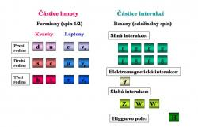
Přehled částic standardního modelu, u částic hmoty má každý kvark a lepton svého antihmotného partnera. Kvarky a antikvarky se pak vyskytují ve třech variantách s různým nábojem silné interakce (barvou). Označuje se většinou jako červená, modrá a zelená.
Veškerá komplikovaná struktura a rozmanitost našeho světa je tvořena částicemi, mezi kterými působí interakce. Dnes víme, že interakce jsou zprostředkovány výměnou částic, říká se jim intermediální bosony . Standardní model, který je současným popisem struktury hmoty a interakcí, se tak skládá z částic hmoty a částic interakcí . Současně jsou jeho součástí teorie, které tři druhy interakcí, které v mikrosvětě působí, popisují. Těmito interakcemi jsou silná interakce, elektromagnetická interakce a slabá interakce. Částice hmoty jsou fermiony a částice interakcí jsou bosony.
Částice hmoty
Částice hmoty se dělí do dvou skupin. V jedné skupině je šestice kvarků a v druhé šestice leptonů . Leptony interagují pouze slabou a pokud jsou elektricky nabité i elektromagnetickou interakcí. Kvarky interagují navíc silnou interakcí. Velikost náboje kvarků je buď třetina nebo dvě třetiny náboje elektronu. Tyto šestice kvarků a leptonů se po dvojicích dělí do tři rodin (někdy se mluví o generacích). Každá následující rodina má výrazně vyšší hmotnost kvarků a nabitého leptonu. V první rodině jsou kvarky u (up - horní) a d (down - dolní) , které tvoří proton i neutron, nabitý lepton elektron a elektronové neutrino ν_{e}. Neutrina nemají elektrický náboj, interagují pouze slabě a mají velmi malou hmotnost. Velikosti hmotností neutrin se zatím nepodařilo určit. V druhé rodině jsou těžší kvarky s (strange - podivný) a c (charm - půvabný) , dále zhruba dvěstěkrát těžší kolega elektronu mion μ a mionové neutrino ν_{μ} . V třetí rodině jsou pak ještě těžší kvarky b (bottom - spodní) a t (top - svrchní) . Někdy se označuje b kvark jako beauty (krásný) a t kvark jako truth (pravdivý). Nejtěžší kvark t má hmotnost téměř dvě stě hmotností protonu. Kolega elektronu v této generaci tauon τ je téměř tří a půl tisíckrát těžší než on. V této generaci leptonů jej doplňuje tauonové neutrino ντ . Ke všem těmto částicím existují ještě partneři ze světa antihmoty. I tyto „antičástice“ jsou po všech stránkách normálními částicemi.
Zvětšit obrázek
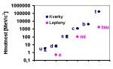
Hierarchie v hmotnostech kvarků a těžkých leptonů. Pro srovnání, hmotnost protonu je téměř 1000 MeV/c^2
Může vzniknout otázka, zda už jsme všechny rodiny objevili, jestli se třeba na novém urychlovači LHC neobjeví nový ještě těžší kvark. Odpověď na tuto otázku částečně známe. Víme, že nemůže existovat další rodina, která by obsahovala neutrino podobné těm předchozím, tedy s malou hmotností. Pro takové tvrzení máme dvě experimentální evidence. První plyne z pozorování rozpadu velmi těžkých intermediálních bosonů slabé interakce Z⁰. Tento elektricky neutrální boson, o kterém se blíže zmíníme za chvíli, je velmi těžký (je více než devadesátkrát těžší než proton) a rozpadá se také na pár neutrino a antineutrino. Pokud by byla hmotnost neutrin v nové rodině podobná hmotnosti těch předchozích, musela by se částice Z⁰ rozpadat i na tato neutrina a antineutrina. Pravděpodobnost rozpadu částice by se zvětšila a její doba života zkrátila. Dnes je doba života Z⁰ bosonu velice přesně změřena a jsou v ní místa jen pro tři možné typy neutrin s malou hmotností. Stejný výsledek dávají i výzkumy ranných stádií vývoje vesmíru. Ve vesmíru existuje kromě mikrovlnného (fotonového) reliktního záření i neutrinové reliktní záření. Tato reliktní neutrina měla značný vliv na počáteční stádia vesmíru a můžeme tak omezit i počet různých lehkých neutrin z kosmologických dat. Oba typy měření ukazují, že taková neutrina jsou pouze tři. Čtvrtá rodina obsahující lehké neutrino už neexistuje. Není ovšem vyloučena rodina, která by obsahovala úplně nový typ velmi těžkého neutrina. Příznaky existence takových neutrin se hledají na každém novém urychlovači, který umožňuje dosáhnout na vyšší energie než předchozí.
Částice interakcí
Bez interakcí bychom se k rozmanitému světu nedostali. Interakce je proces, při kterém dochází k přenosu energie a hybnosti i dalších fyzikálních veličin, které v konečném důsledku vedou ke změně hybnosti a energie částic nebo k jejich přeměně, kreaci či anihilaci. Umožňuje tak vznik vázaného systému částic i jeho rozpad, jakož i přeměnu a rozpad samotných částic. Jak už bylo zmíněno, je interakce zprostředkována výměnou částic, tzv. intermediálních bosonů. V mikrosvětě působí tři ze známých interakcí.
Nejznámější je elektromagnetická interakce , která je spojena s elektrickým nábojem . Ten může být kladný a záporný a jeho velikost je kvantovaná. Je zprostředkován výměnou intermediálních bosonů, kterými jsou známé fotony s nulovou klidovou hmotností a elektrickým nábojem. Kvantová teorie, která tuto interakci popisuje, se označuje jako kvantová elektrodynamika . V přírodě vzniká řada objektů vázaných elektromagnetickou interakcí. Mezi ně patří například atom. Je silná tendence vytvářet kombinací záporných a kladných nábojů elektricky neutrální objekty.
Náboj silné interakce byl označen jako barevný náboj . Existují tři druhy tohoto náboje, které jsou označovány jako červený, zelený a modrý (u antičástic antičervený, antizelený a antimodrý). Intermediálními bosony, které zprostředkují tuto interakci, je osmice gluonů . Ty jsou na rozdíl od fotonů nositeli barvy a antibarvy, což silnou interakci činí daleko komplikovanější. Stejně jako u elektromagnetické síly může kombinace kladných a záporných nábojů vytvořit elektricky neutrální systém, lze kombinací různých barevných nábojů získat objekt neutrální (bílý, bezbarvý) z hlediska barevného náboje. Takovou neutrální kombinací jsou případy, kdy máme stejné zastoupení všech tří barev (případně všech tří antibarev) nebo kombinace barvy a její antibarvy. Jak si za chvíli ukážeme podrobněji, vyskytují se v našem okolí pouze objekty neutrální z hlediska barevného náboje. Kvantovou teorií, která popisuje silné interakce, je kvantová chromodynamika .
Intenzita slabé interakce je velmi malá. Tato interakce nedokáže tvořit vázané systémy. Její důležitost spočívá v tom, že jsou ji dovolený některé procesy, které mají předchozí interakce zakázané. Takže díky ní probíhá například rozpad beta radioaktivních jader. Neutrina, která nemají elektrický ani barevný náboj, interagují pouze slabou interakcí. Slabá interakce je natolik spojená s elektromagnetickou, že jí popisuje kvantová teorie popisující společně slabou a elektromagnetickou interakci a označuje se jako elektroslabá teorie . Právě tato teorie předpověděla existenci intermediálních bosonů, které zprostředkují slabou interakci. Jsou tři, dva nabité W⁺ a W⁻ a jeden neutrální Z⁰. Jejich hmotnost je velmi velká (okolo stovky hmotností protonu). I když je tedy boson Z⁰ „bratr“ fotonu, je to hodně obézní bratr. Tuto jeho obezitu způsobuje tzv. Higgsův mechanismus , který bude popsán v následujícím odstavci.
Zvětšit obrázek
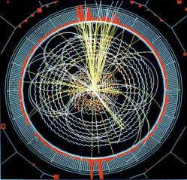
Simulace toho, jak by mohla vypadat detekce higgse pomocí experimentu CMS, který bude pracovat na urychlovači LHC

Existence všech částic standardního modelu byla experimentálně potvrzena. Jediná, která je zatím pouze hypotetická, je Higgsův boson . Je to částice kterou potřebuje teorie elektroslabé interakce k tomu, aby vysvětlila rozdíl mezi klidovou hmotností fotonů a velmi velkou hmotností bosonů W⁺, W⁰ a Z⁺. Řešením je již zmíněný proces, který se podle svého objevitele, skotského fyzika Higgse, nazývá Higgsův mechanismus. Ten předpokládá existenci tzv. Higgsova pole, které je spojeno s existencí Higgsova bosonu. Při prodírání Higgsovým polem nabývají intermediální bosony slabé interakce své hmotnosti. V nejjednodušší formě teorie je Higgsův boson jeden, v složitějších variantách můžou být čtyři (dva neutrální označované jako H₁, H₂ a dva nabité H⁺ a H⁻) i více. Nalezení higgse je jedním z hlavních úkolů právě dokončovaného urychlovače LHC v laboratoři CERN. Z experimentů na předchozích největších urychlovačích víme, že jeho klidová hmotnost je větší než zhruba 110 GeV/c² (zmíněný více než stonásobek hmotnosti protonu). Aby se teorie elektroslabých interakcí chovala „mravně“ v širokém rozmezí energií, musí být jeho klidová hmotnost menší než zhruba 200 GeV/c². V každém případě by tedy měl být v dosahu urychlovače LHC. Jeho neobjevení by tak znamenalo nutnost najít náhradu Higgsova mechanismu a velkou výzvu pro teoretické fyziky. Podrobněji jsem lov na higgse popsal zde. Všechny částice standardního modelu jsou popisovány jako bodové. Experimentálně pak víme, že je jejich rozměr menší než 10⁻¹⁸ m. To je nejmenší rozměr, který dokážeme „vidět“ pomocí těch největších současných urychlovačů.

A co gravitace?
A co poslední čtvrtá známá interakce? Tou je gravitační interakce . Její intenzita je v běžných podmínkách (při současných běžně dostupných hustotách energie) v mikrosvětě zanedbatelně malá. To, že se nejvíce projevuje v našem makrosvětě, je dáno jejím nekonečným dosahem a tím, že má jen jeden druh náboje – hmotnost . Vliv jednotlivých příspěvků se tak pořád sčítá a nelze jej odstínit, jako je tomu v případě elektromagnetické interakce. Doposud nemáme kvantovou teorii gravitace, která by ji dokázala popsat podobným způsobem, jak to například u elektromagnetické interakce umožňuje kvantová elektrodynamika. Pokud budeme chtít najít jednotnou teorii popisující komplexně všechny čtyři interakce, musíme kvantovou teorii gravitace vypracovat. Intermediální boson, který by měl být zodpovědný za gravitační intertakci, se označuje jako graviton. Tato částice s nulovou klidovou hmotností zatím nebyla přímo pozorována a je otázka, jestli se to někdy podaří. V současnosti je z pozorování změn oběžných drah binárních pulsarů nepřímo potvrzena existence gravitačních vln. Začaly fungovat detektory, které by měly umožnit jejich přímé pozorování. I po úspěchu v této oblasti budeme od detekce jednotlivých gravitonů velmi daleko. Tak jako bylo ještě hodně daleko od prokázání existence radiových vln (elektromagnetického záření) k detekci jednotlivých fotonů.

Ač elementární, přece jen složené
Z historie našeho vědeckého poznání nám zůstala řada nelogických názvů, které jsou však natolik zavedené, že je není účelné měnit a stále se používají. Stále je atom atomem od řeckého slova atomos (nedělitelný), i když dnes dobře víme, že dělitelný je.
Zvětšit obrázek
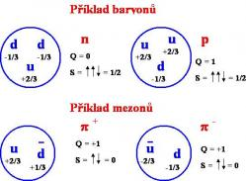
Složení nejjednodušších baryonů (proton a neutron) a mezonů (mezony pí). Celkový náboj Q hadronu je dán součtem nábojů kvarků, které je tvoří (náboj kvarku u je +2/3 náboje elektronu a náboj kvarku d je -1/3 náboje elektronu). Celkový spin s je dán skládáním spinů kvarků. Baryony jsou fermiony a mezony bosony.
Stejně tak se jako elementární částice často označují i částice, které elementární nejsou, naopak jsou vázanými stavy kvarků. Správnější by bylo označovat jako elementární (fundametální) částice pouze částice standardního modelu a ne vázané systémy kvarků.

Zatímco leptony se mohou vyskytovat volně, kvarky se v normálních podmínkách volně vyskytovat nemohou a existují pouze ve vázaných systémech, které jsou částicemi označovanými jako hadrony . Hadrony jsou tedy částice interagující silnou interakcí a složené z kvarků. Jsou dvou typů. Baryony se skládají ze tří kvarků a antibaryony ze tří antikvarků. Jsou tedy opět fermiony (suma tři poločíselných čísel je poločíselné číslo). Mezony pak z jednoho kvarku a antikvarku a jsou bosony (suma dvou poločíselných čísel je číslo celočíselné). Baryonů a mezonů existuje velmi velké množství (jejich počty se počítají na stovky). Dva úplně identické kvarky se, jsou fermiony, nemohou vyskytovat ve stejném stavu. To byl jeden z historických důvodů zavedení barevného náboje do fyziky. Pozorovaly se totiž částice, které obsahovaly tři stejné kvarky (i se stejnou projekcí spinu) v základním stavu. Musely se tudíž lišit v nějaké nové fyzikální veličině a tou byl barevný náboj. Nové částice můžeme obdržet i tím, že po dodání energie, díky níž se některý z kvarků dostane ze základního stavu do vybuzeného. Známe tak nukleony složené z u a d kvarků - protony (kvarkové složení uud) a neutrony (kvarkové složení udd) - v základním stavu i jejich excitace, které se označují jako N* rezonance . Jako rezonance se označují všechny hadrony s velmi krátkou dobou života (řádově 10⁻²² s). Hadronům, které obsahují podivný kvark s, se říká podivné. Baryony s podivným kvarkem se označují jako hyperony . Plejáda hadronů a přehled jejich vlastností dnes zaujímá mnohostránkové tabulky a jejich počet stále roste.
Zvětšit obrázek
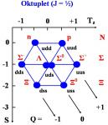
Hadrony se dělí do multipletů. Jako příklad si můžeme uvést baryonový oktet, který obsahuje proton a neutron. Částici charakterizuje její náboj Q, fyzikální veličina projekce izospinu Tz, kterou vnáší kvarky u a d a také podivnost S, kterou vnáší kvark s.
V souvislosti s tím, že nepozorujeme volné kvarky, se může objevit otázka: Jak je tedy experimentálně prokázána jejich existence? Jedním z důkazů je, že pomocí nich můžeme vysvětlit všechny pozorované hadrony i zhruba poměry mezi jejich hmotnostmi a jiné vlastnosti. Další možností jejich „pozorování“ je využití rozptylu částic na hadronech. Pomocí rozptylu částic alfa získaných z rozpadu alfa poprvé „uviděl“ Rutheford atomové jádro. Pro to, abychom uviděli kvarky, musíme použít částice s daleko vyššími kinetickými energiemi. Používají se k tomu elektrony z urychlovače s velmi vysokými energiemi. Pomocí těchto elektronů se v protonech a neutronech objevila rozptylová centra (označují se jako partony), jejichž náboj, spin a další vlastnosti odpovídají vlastnostem přisuzovaným kvarkům. Třetí proces, ve kterém se kvarky přímo „zviditelňují“, je srážka hadronů s velmi vysokou energií. V takovém případě se srážejí přímo jednotlivé kvarky. Při takové srážce dochází k přeměně velké části kinetické energie srážejících se kvarků na energii produkce párů kvarku a antikvarku. Vzniká velké množství kvarků a antikvarků, které se čistě z kinematických důvodů (zákon zachování energie a hybnosti) pohybují ve směru pohybu rozptýlených původních kvarků. Kvarky a antikvarky nemohou zůstat volné, a proto se pospojují do hadronů (takový proces se nazývá hadronizací). Vznikají dva výtrysky hadronů, které se pohybují v opačném směru a každý z nich nese celkovou informaci o původním kvarku. Pozorování těchto výtrysků a jejich vlastností je zviditelněním kvarků.
Ještě si připomeňme, jak je z částic tvořena pestrost našeho světa. Protony a neutrony jsou vázány silnou jadernou interakcí do atomových jader. Ačkoliv za ní stojí silná interakce, je silná jaderná síla zprostředkována mezony, které si nukleony v jádře mezi sebou vyměňují. Jistou analogií je molekulární vazba, která drží atomy v molekule. Stojí za ní sice elektromagnetická interakce, ale vytváří ji sdílení elektronů. Mezonů je velký počet a charakter interakce, kterou způsobují, závisí na jejich vlastnostech. Může byt přitažlivá nebo odpudivá. Různý je i její dosah, čím těžší je mezon, tím kratší je dosah síly, kterou způsobuje. Máme tak přitažlivou jadernou sílu na větší vzdálenosti a odpudivou na vzdálenosti velmi krátké. K popsaným atomovým jádrům přidáme pomocí elektromagnetické interakce elektrony a dostaneme atomy. Ty pak spojí zmíněné molekulární vazby do jednoduchých i velmi složitých molekul.

Zvětšit obrázek
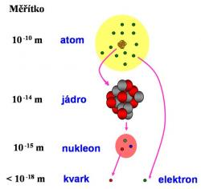
Rozměrová škála jednotlivých struktur, které tvoří hmotu našeho světa.
Další, tentokrát hypotetické vázané systémy kvarků a gluonů
Ještě se zmiňme o hypotetických složitějších vázaných kvarkových systémech. Teorie popisující silnou interakci nezakazuje a priory (nebo to aspoň zatím nevidíme) vázané systémy s jiným počtem kvarků než dva (mezony) a tři (baryony). Jedinou podmínkou je, že dohromady musí z hlediska náboje silné interakce (barvy) tvořit neutrální (bílý) objekt. To například splňuje i systém složený ze dvou kvarků a dvou antikvarků (tetrakvark) nebo ze čtyř kvarků a jednoho antikvarku (pentakvark). Takové systémy se intenzivně hledají a už několikrát v historii byl jejich objev ohlášen. Zatím se však vždy ukázalo, že šlo o planý poplach. Podrobný rozbor situace kolem jejich hledání jsem napsal pro časopis Kozmos.
Zvětšit obrázek
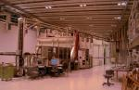
V roce 2003 ohlásil pozorování pentakvarku i japonský experiment LEPS, podobná pozorování ohlásilo i několik dalších experimentů. Ovšem jiné experimenty je vyvracejí. Otázka pentakvarků je tak stále otevřená. (Obrázek ze stránek experimentu LEPS)
Jak bylo popsáno v části věnované interakcím, jsou intermediální bosony silných interakcí, gluony, nositeli barevného náboje. Mohou tedy mezi sebou interagovat silnou interakcí a v principu vytvořit vázaný systém složený pouze z gluonů. Takový, zatím čistě hypotetický objekt, se označuje jako gluonium nebo glueball a intenzivně se na každém novém velkém urychlovači hledá.
Na závěr bych se zmínil ještě o jednom hypotetickém objektu vázaném silnou interakcí. Za normálních podmínek se nemohou kvarky vyskytovat volně a musí být vázány do hadronů. Při velmi vysokých hustotách energií však může vzniknout systém volných kvarků a gluonů, který se označuje jako kvark-gluonové plazma. O jeho objevu a vlastnostech si lze přečíst například zde. Existuje hypotetická možnost, že v případě správné příměsi podivných kvarků s, budou „kapky“ tohoto „podivného“ kvark-gluonového plazmatu metastabilní i za normálních podmínek. Tyto objekty se označují jako podivnůstky (anglicky strangelet) a i na urychlovači LHC se budou intenzivně hledat.

Částice spojené s teoriemi (hypotézami) sjednocujícími popis interakcí
Všechny další částice, o kterých budeme mluvit, jsou také zatím pouze hypotetickými. Řadu takových částic vyžadují teorie, které se snaží sjednotit popis všech interakcí. Mluvíme sice o teoriích, ale, korektněji řečeno, jde zatím pouze o hypotézy, které na své experimentální potvrzení nebo vyvrácení teprve čekají.
Leptokvarky
Mezi vlastnostmi kvarků a leptonů existuje řada podobností (symetrií). Jak u kvarků, tak i leptonů máme tři generace částic, velmi ostře oddělené hmotnostmi (neplatí u neutrin, která mají velmi malou hmotnost všechna). Původ těchto symetrií by měla vysvětlit teorie, která by sjednotila elektroslabou a silnou interakci. Tyto teorie, označované jako teorie velkého sjednocení, předpovídají částice, které by mohly přeměňovat kvarky na leptony a naopak. Tyto částice se označují jako leptokvarky nebo také X,Y bosony . Bosony X by měly mít elektrický náboj -4/3e a náboj bosonů Y by měl být -1/3e. Důsledkem jejich existence by byl i rozpad protonu. Ovšem tento rozpad, pokud existuje, by měl jen velmi malou pravděpodobnost. Zatím nebyl pozorován a z experimentu plyne doba života protonu delší než 10³² let. Tato dlouhá doba života je důsledkem i velmi velké hmotnosti leptokvarků, která by měla být 10¹⁵krát větší než hmotnost protonu. Pozorování rozpadu protonu by bylo nepřímým důkazem existence těchto částic. Jejich přímé potvrzení je zatím neřešitelným problémem. Svou hmotností jsou daleko mimo dosah současných i v současnosti představitelných urychlovačů. Mohly by vznikat v závěrečných stádiích vypařování černých miniděr Hawkingovým zářením. Existence takových objektů v našem vesmíru je však zatím také pouze hypotetická. Pokud by však při jejich vypaření leptokvarky vznikaly, velmi rychle by se rozpadaly.
Je možné ještě připomenout, že v některých teoriích velkého sjednocení se objevují i magnetické monopóly . Částice, které reprezentují jeden pól magnetu. Původně zavedl tyto částice Paul Dirac, aby zrovnoprávnil popis elektřiny a magnetismu. Hmotnost monopólů předpovídaných teoriemi velkého sjednocení by byla podobná hmotnosti leptokvarků. Na rozdíl od nich by mohly být stabilní nebo s dlouhou dobou života. Z ranných fází vývoje vesmíru by tak mohly pocházet reliktní monopóly. Pokud monopóly existují, je třeba vysvětlit, proč nepozorujeme velký počet reliktních monopólů. Takovým vysvětlením by mohly být inflační modely vesmíru (blíže o kosmologii z pohledu experimentálního fyzika zde).
Zvětšit obrázek
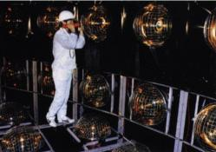
Rozpad protonu se snažil pozorovat i detektor Kamiokande, který se později proslavil pozorováním neutrin (zdroj stránky Kamiokande a SuperKamiokande)
Supersymetrické částice
V článku o lovu na antihmotu ve vesmíru jsme narazili na další velkou skupinu částic předpovídanou teoriemi sjednocujícími popis interakcí - supersymetrické částice. Supersymetrické teorie vysvětlují symetrie mezi bosony a fermiony. Předpovídají, že ke každé známé částici by měl existovat supersymetrický partner , jehož hmotnost by měla být mnohem větší. Dále by se lišily v tom, že supersymetričí partneři fermionů budou bosony. Jejich název se tvoří předponou s-. Máme tedy s-kvarky a s-leptony (s-elektrony, s-miony, s-tauony a s-neutrina ). Supersymetrickými partnery bosonů budou fermiony. U nich se název tvoří příponou ino. Máme tedy gluino, fotino , Wino , Zino , gravitino i higgsino . Rozpad těžkých supersymetrických částic na lehčí by probíhal relativně rychle. Ovšem ta nejlehčí z nich by se musela rozpadat na částice standardního modelu a takový rozpad by měl velmi malou pravděpodobnost. Pokud tedy supersymetrické částice existují a během velmi horkých počátečních fázích vývoje vesmíru vznikly, měly by existovat reliktní supersymetrické částice (ty nejlehčí z nich). Ty by vyplňovaly vesmírný prostor podobně jako reliktní fotony a neutrina. Jen díky jejich vysoké hmotnosti by se více koncentrovaly k centrům gravitace. A právě tyto částice by mohly vysvětlit pozorovanou temnou hmotu. Nevíme, která ze supersymetrických částic má nejmenší hmotnost. Víme jen, že musí být neutrální, protože jinak by temná hmota interagovala elektromagneticky a nebyla by temná. Nevíme tedy, jestli je to gluino, fotino, Zino nebo něco jiného. Nevíme ani, jestli to třeba není směs těchto částic. Důležitou vlastností kvantového světa je totiž, že některé stavy nejsou čisté a mohou být smíchány. Když bychom si to představili v makrosvětě, znamenalo by to, že kromě kočky, psa a myši, existuje i smíšený stav, který se skládá z určitého procenta z kočky, psa i myši. Proto se obecně neutrální supersymetrické částici s nejnižší hmotností říká neutralino .
Při popisu gravitonu jsem se zmínil, že, díky jeho malé hmotnosti a velice malé intenzitě gravitační interakce, je jeho přímá detekce zatím jen těžko představitelná. Jednou z možností nepřímého prokázání jeho existence by mohlo být pozorování gravitina a zkoumání jeho vlastností.
Struny
Teorie, které aspirují na to být finální teorií popisující komplexně všechny interakce a obsahující i kvantovou teorií gravitace, jsou strunové teorie. Tyto teorie jsou supersymetrickými teoriemi a obsahují pochopitelně i standardní model. Podle těchto teorií jsou pozorované částice standardního modelu i předpokládané částice sjednocovacích teorií různými vibračními módy objektů o rozměrech 10⁻³⁵ m, které byly nazvány struny. Strunové teorie jsou fyzikálně i matematicky velice náročné a spočítat pro ně kvantitativní předpovědi pro energie dostupné na našich urychlovačích se zatím nedaří. Trochu více jsem o tom již psal.
Teorie technicoloru a další
Byly a jsou i jiné verze sjednocovacích teorií. Jednou z nich je například teorie technicoloru. Ona i další teorie předpovídají řadu různých částic. Jejich objevení nebo experimentální vyloučení jejich existence jsou pak základními prubířskými kameny, které vedou k potvrzení nebo zavrhnutí dané teorie. Hodně se v této oblasti očekává od urychlovače LHC.
Nakonec se zmíním ještě o několika příkladech částic, které nevyplývají ze sjednocovacích teorií.
Zvětšit obrázek
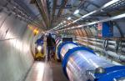
Řadu otázek o existenci částic předpovídaných různými teoriemi by mohl vyřešit urychlovač LHC (zdroj CERN).

Axiony
Velmi často se objeví nové předpovědi částic při řešení problémů s narušením symetrií a zákony zachování ve fyzice. Mezi takové případy patří i axiony. Objevují se v roce 1977 v souvislosti s pracemi nad teorií silné interakce - kvantové chromodynamiky. Ta v principu dovoluje narušení kombinované CP-symetrie. Tedy, že některé fyzikální procesy probíhají o trochu jinak ve světě, který je zrcadlový vůči našemu (P-symetrie) a všechny částice jsou zaměněny za antičástice a antičástice za částice (C-symetrie). Velikost tohoto narušení z kvantové chromodynamiky neplyne a musí se experimentálně určit. Změřený příslušný parametr narušení je třeba do teorie vložit. Ukázalo se, že toto narušení je extrémně malé a za pozorovaným narušením CP symetrie nestojí silná ale slabá interakce. Pro znalce jen připomenu, že experimentálním faktem, který to dokazuje, je velmi malá hodnota elektrického dipólového momentu neutronu. Nastal tak problém, proč je hodnota narušení CP-symetrie u silné interakce tak extrémně malá. Ve zmíněném roce 1977 navrhli Roberto Peccei a Helen Quinnová mechanismus, který byl nazván jejich jménem. Ten zavádí do popisu silné interakce novou symetrii, která je spontánně narušena a řeší popsaný problém. Ovšem zároveň předpovídá existenci nové velmi lehké částice (o mnoho řádů lehčí než elektron, srovnatelné s hmotností neutrin) s nulovým nábojem i spinem, která byla označena jako axion. Takto podrobný popis důvodů zavedení axionu jsem zde uvedl, abych dokumentoval skutečnost, že zavedení nových částic je velmi často vyvoláno objevením nové interakce (pole) nebo objevením narušení nějakého zákona zachování (spojeným s nějakou fyzikální symetrií) a jejich konkrétními projevy. Logika a krása takového řešení je však jasně vidět až při znalosti souvisejících teorií.
Také axiony se intenzivně hledají. Několikrát už bylo ohlášeno pozorování náznaků jejich existence. Naposledy v minulém roce. Zdá se však, že zatím to vždy byl planý poplach, který se později nepotvrdil. Pokud by byl zájem, pokusil bych se historii a současnost hledání axionů popsat v některém z příštích článků pro Osla.

Zvětšit obrázek
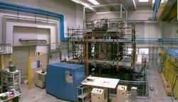
Italský experiment PVLAS hledá projevy axionů při zkoumání vlastností vakua pomocí průchodu polarizovaného světla velmi silným magnetickým polem. V roce 2006 ohlásil náznaky projevů existence axionů. V roce 2007 na základě vylepšení experimentálního zařízení svá předchozí pozorování dementoval. Jednalo se o přístrojové chyby (zdroj PVLAS).

Částice spojené s temnou energií
Už jsme se zmínily o souvislosti, která je v kvantové fyzice mezi fyzikálním polem a částicí. V nedávné době se prokázalo z pozorování supernov I. druhu, že se rozpínání vesmíru v posledním období místo zpomalování zrychluje. Za to je zodpovědný speciální druh pole, který se nazývá jako temná energie. V současnosti je potvrzeno studiem vlastností reliktního záření, že temná energie tvoří přes 70% hmoty ve vesmíru. Každé pole je spojeno s částicí a tak i za temnou energií by se měly skrývat částice, které například C. Wetterich označuje jako „kosmony “. Ovšem úvahy o této částici (nebo částicích) jsou opravdu velmi spekulativní, protože temná energie je doposud velkou záhadou a víme o ní jen velmi málo.

Zvětšit obrázek
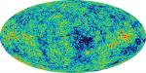
Existenci temné hmoty i temné energie potvrzují i pozorování fluktuací teploty reliktního mikrovlnného záření (zdroj NASA).

Co říci na závěr?
Ukázali jsme si řadu existujících částic, které jsou součástí standardního modelu. Zmínili jsme si řadu hypotetických částic, které předpovídají sjednocovací teorie. Také některé případy dalších, které potřebují jiné teorie. Potvrzení či vyvrácení existence předpovídaných částic je klíčové pro ověření správnosti předkládaných teorií.
Přehled světa částic už byl napsán mnohokrát a i na internetu se řada takových popisů dá najít. Každý z autorů přistupuje k výkladu trochu jinak, má jiný akcent i styl jazyka. Je dobře, že si čtenář může vybrat právě takový zdroj, který mu nejlépe vyhovuje. S nadějí, že alespoň pro některého ze čtenářů bude i můj výklad přínosný, jsem se odhodlal k sepsání dalšího v dlouhé řadě. Na závěr bych přidal odkazy na některé z popisů jiných a většinou kompetentnějších autorů.
Aldebaran
Dobrodružství s částicemi
Wikipedia

Autor: Vladimír Wagner
Datum:05.04.2008 v 15:52

Zvětšit obrázek
Přehled částic standardního modelu, u částic hmoty má každý kvark a lepton svého antihmotného partnera. Kvarky a antikvarky se pak vyskytují ve třech variantách s různým nábojem silné interakce (barvou). Označuje se většinou jako červená, modrá a zelená.

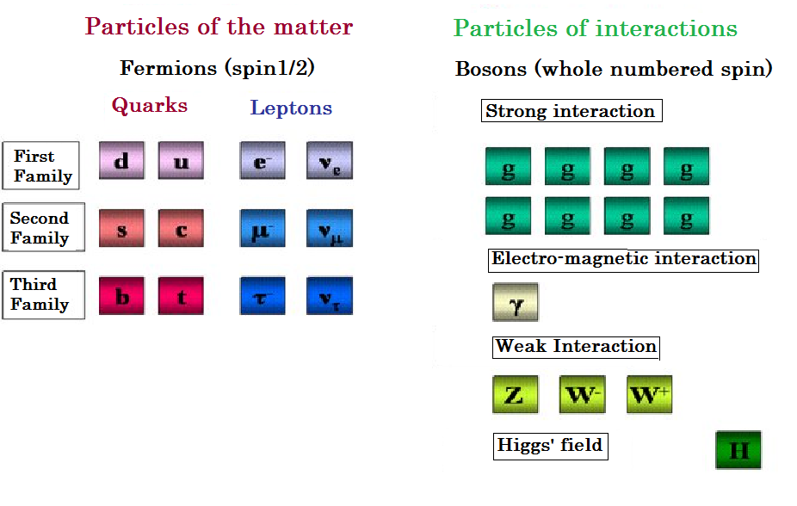
(0)

Floor C of the Pyramid
Chemical elements and periodical table

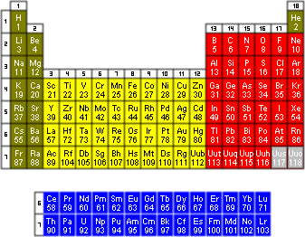

(0)

Floor D of the pyramid:
Inorganic chemistry (This floor constitutes of all inorganic substances and all chemical reactions between them)

http://oldwww.chemik-online.com/view.php?cisloclanku=2004081501

Soli kyselin
Soli jsou sloučeniny skládájící se z kationtů kovů (popř. skupinou NH⁴⁺) a aniontu kyselin.
Ox. číslo | Koncovka | Název | Vzorec
I | nan | chlornan sodný | NaClO
II | natan
III | itan
IV | ičitan | uhličitan hořečnatý | MgCO₃
V | ičnan  ečnan | dusičnan sodný  fosforečnan vápenatý | NaNO₃  Ca₃(PO₄)₂
VI | an | síran hlinitý | Al₂(SO₄)₃
VII | istan | manganistan draselný | KMnO₄
VIII | ičelan

oxidy
- dvouprvkové (binární) sloučeniny kyslíku
- O-II
oxid sodný Na₂O
oxid vápenatý CaO
oxid hlinitý Al₂O₃
oxid křemičitý SiO₂
oxid fosforečný P₂O₅
oxid sírový SO₃
oxid manganistý Mn₂O₇
oxid rutheničelý RuO₄

sulfidy
- binární sloučeniny síry
- S^{-II}
sulfid měďnatý Cu₂S
sulfid kademnatý CdS
sulfid arsenitý As₂S₃
sulfid ciničitý SnS₂
sulfid antimoničný Sb₂S₅
sulfid amonný (NH₄)₂S

halogenidy
- soli halogenovodíkových kyselin – HF, HCl, HBr, HI
- fluoridy, chloridy, bromidy, jodidy
- vždy ^{–I}
fluorid draselný KF
chlorid vápenatý CaCl₂
bromid hlinitý AlBr₃
jodid olovičitý PbI₄
fluorid arseničný AsF₅
chlorid scandový ScCl₆
jodid technecistý TcI₇
fluorid osmičelý OsF₈

hydroxidy
- skupina (OH)^{-I}
hydroxid sodný NaOH
hydroxid barnatý Ba(OH)₂
hydroxid železitý Fe(OH)₃
hydroxid amonný NH₄OH
hydroxid ytritý Y(OH)₃

peroxidy
- O^{-I} , vyskytuje se v O₂
peroxid draselný K₂O₂
peroxid sodný Na₂O₂
peroxid vápenatý CaO₂
peroxid barnatý BaO₂

hydridy
- prvky I.A a II.A skupiny
- H^{-I}
hydrid lithný LiH
hydrid draselný KH
- prvky III. – VI.A - jednoslovný název odvozený od latinského názvu prvku
- koncovka –an

III. VI.
boran BH₃ methan CH₄
alan AlH₃ silan SiH₄
galan GaH₃ germanan GeH₄
indan InH₃ stannan SnH₄
thalan TlH₃ plumban PbH₄

V. VI.
amoniak (azan) NH₃ voda H₂O
fosfan PH₃ sulfan H₂S
arzan AsH₃ selan H₂Se
stiban SbH₃ telan H₂Te
bismuthan BiH₃ polan H₂Po
- prvky VII. skupiny mají jednoslovný název vycházející ze schématu prvek + o + vodík
fluorovodík HF
bromovodík HBr
chlorovodík HCl
jodovodík HI

kyanidy
kyanid sodný NaCN
kyanid vápenatý Ca(CN)₂
kyanid železitý Fe(CN)₃
kyselina thiokyanatá (rhodanovodíková) HSCN

kyslíkaté kyseliny
- schéma: H_{X} A O_{Y} (A představuje kyselinotvorný prvek)
kyselina dusičná HNO₃
kyselina sírová H₂SO₄
kyselina rhénistá HReO₄
kyselina seleničitá H₂SeO₃
kyselina chlorná HCLO
kyselina boritá HBO₂
kyselina manganová H₂MnO₄
kyselina chlorečná HClO₃

• kyseliny s větším počtem H
H B O₂ H I O₄
H₂ O H₂ O
H₃BO₃ – kys. trihydrogenboritá H₃IO₅ – kys. trigydrogenjodistá
kyselina tetrahydrogengermaničitá H₄GeO₄
kyselina hexahydrogentelurová H₆TeO₆
• polykyseliny
- obsahují více atomů kyselinotvorného prvku
kyselina disírová H₂S₂O₄
kyselina trichromová H₂Cr₃O₁₀
kyselina tetrahydrogentetrafosforečná H₄P₄O₁₂
• thiokyseliny
- thio = S
- odvozujeme z kyslíkatých kyselin náhradou kyslíku sírou
O^{-II} → S^{-II}
H₂CO₃ → H₂CO₂S – kyselina thiouhličitá
H₂COS₂ – kyselina dithiouhličitá
H₂CS₃ – kyselina trithiouhličitá
kyselina tetrahydrogentetrathiotetrafosforečná H₄P₄O₈S₄
kyselina trihydrogendithioarseničná H₃AsO₂S₂
kyselina thiosírová H₂S₂O₃
kyselina thisiřičitá H₂S₂O₂
soli kyslíkatých kyselin
dusičnan draselný KNO₃
dusičnan olovnatý Pb(NO₃)₂
síran sodný Na₂SO₄
síran hlinitý Al₂(SO₄)₃
chlornan vápenatý Ca(ClO)₂
bromistan cobaltitý Co(BrO₄)₃
dusitan draselný KNO₂
antimoničnan cademnatý Cd(SbO₃)₂
fosforečnan thalitý TlPO₄

hydrogensoli
- obsahují vodík
hydrogensíran vápenatý Ca(HSO₄)₂
hydrogenuhličitan železitý Fe(HCO₃)₃
dihydrogenboritan zinečnatý Zn(H₂BO₃)₂
hydrogengermaničitan tridraselný K₃HGeO₄
thiokyanatan draselný KSCN
trihydrogenhexathiotetraarseničnan ruhenitý RuH₃As₄O₇S₆
hydrogensulfid draselný KHS
hydrogensulfid vápenatý Ca(HS)₂
hydrogenperoxid lithný LiHO₂
hydrogenperoxid barnatý Ba(HO₂)₂

hydráty solí
pentahydrát síranu mědnatého CuSO₄ . 5 H₂O
dihydrát síranu vápenatého CaSO₄ . 2 H₂O
hexahydrát chloridu hlinitého AlCl₃ . 6 H₂O
hemihydrát síranu vápenatého CaSO₄ . ½ H₂O
oktadekahydrát síranu hlinitého Al₂(SO₄)₃ . 18 H₂O

podvojné soli
- 2 různé kationty, 2 různé anionty
síran draselnohlinitý KAl(SO₄)₂
uhličitan draselnosodný KNaCO₃
siřičitan vápenatohořečnatý CaMg(SO₃)₂

==================================================================.

Názvosloví anorganických sloučenin
- Názvosloví dvouprvkových sloučenin
  - Názvosloví oxidů
  - Názvosloví peroxidů
  - Názvosloví bezkyslíkatých kyselin
  - Názvosloví bezkyslíkatých solí
  - Názvosloví hydridů
  - Názvosloví interhalogenových sloučenin
- Názvosloví víceprvkových sloučenin
  - Názvosloví hydroxidů
  - Názvoslový kyslíkatých kyselin
  - Názvosloví kyslíkatých solí
  - Názvosloví hydrogensolí
  - Názvosloví směsných a podvojných solí
  - Názvosloví komplexních sloučenin

Floor E of the Pyramid
………….. http://www.martinsvehla.cz/databaze/
Organic chemistry – chemistry of carbon substances including all reaction mechanisms.

Izomerie organických sloučenin
Uhlovodíky
Alkany [vzorce] [reakce]
Cykloalkany [vzorce]
Alkeny a alkadieny [vzorce] [reakce]
Alkiny [vzorce] [reakce]
Areny [vzorce] [reakce]

Příklad alkánů →
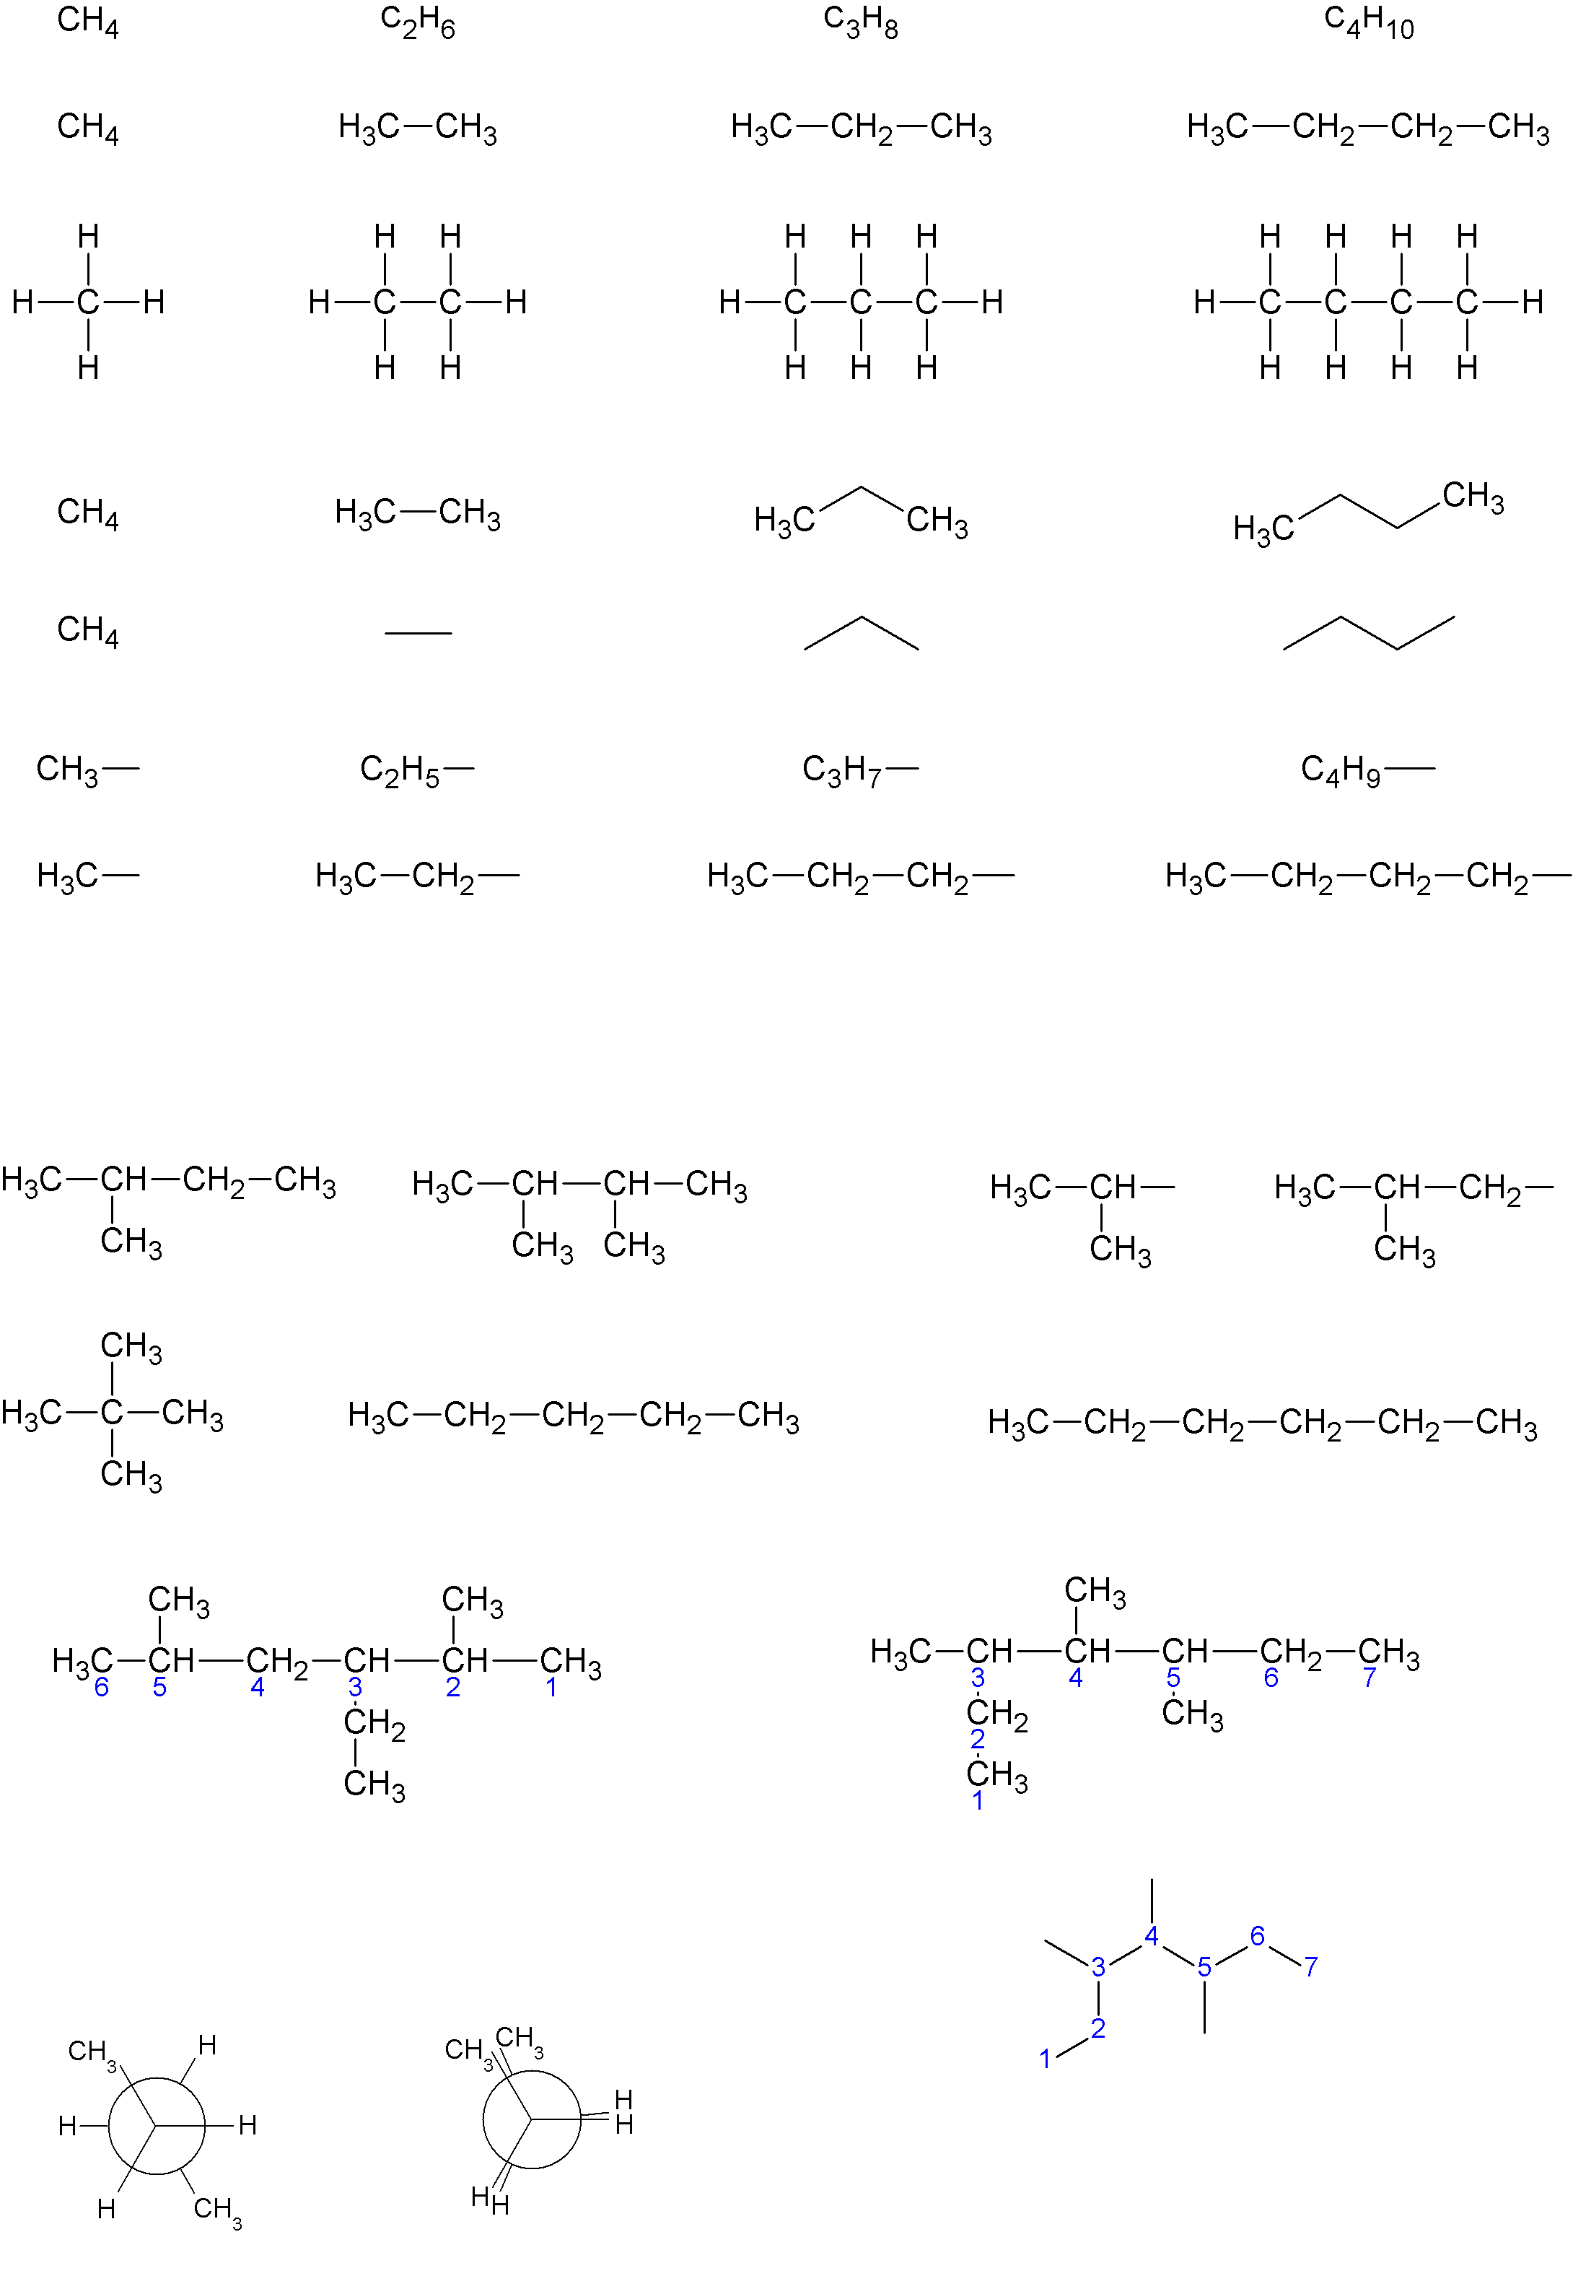

A další příklad organických sloučenin : kyseliny karboxylové
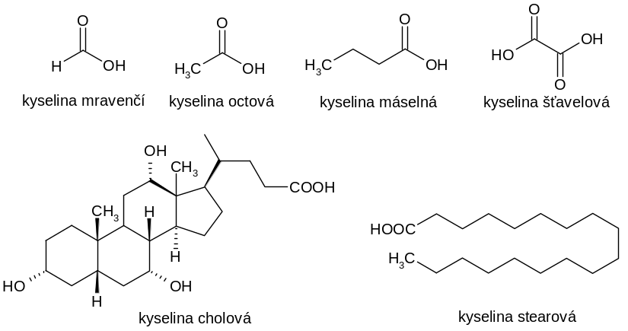

nebo :

http://www.wigym.cz/nv/wp-content/uploads/docs/opory/chemie2.pdf
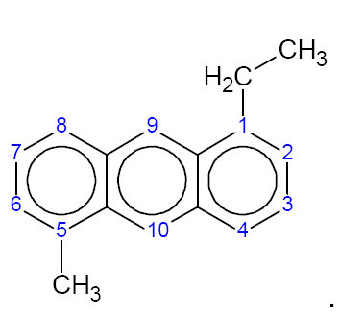
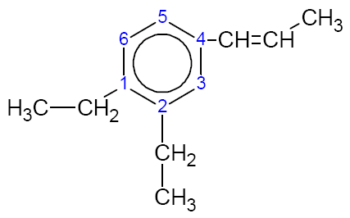

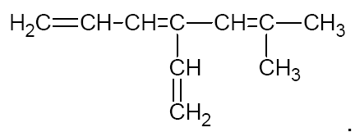

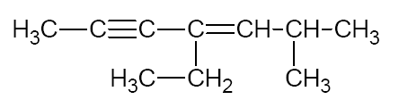

Příklady:
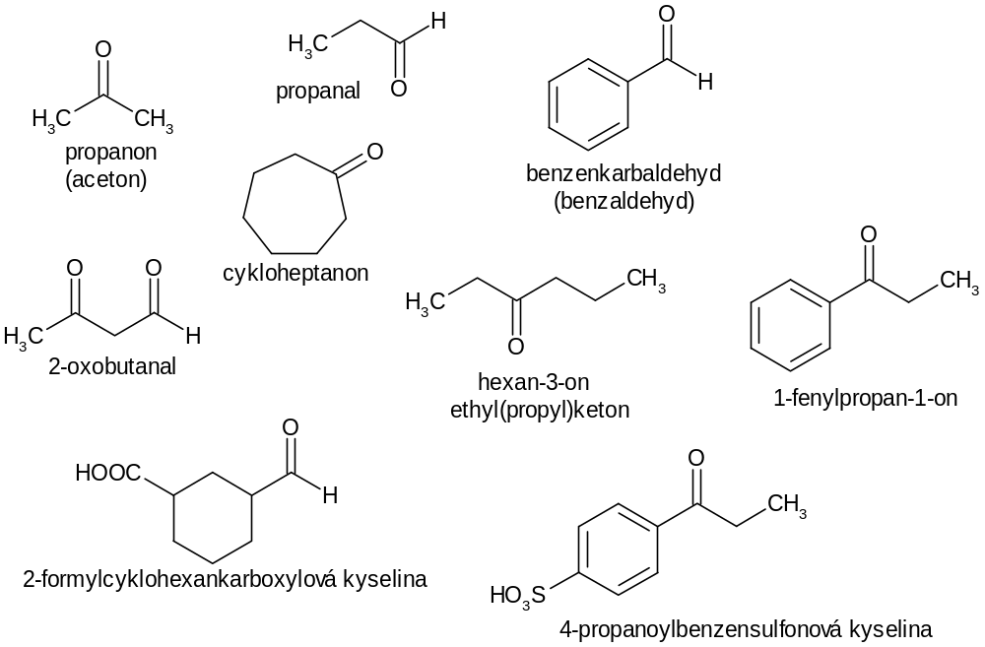

- Nukleofilní adice

mechanismus A – pokud je reagentem slabý nukleofil v přítomnosti silné kyseliny

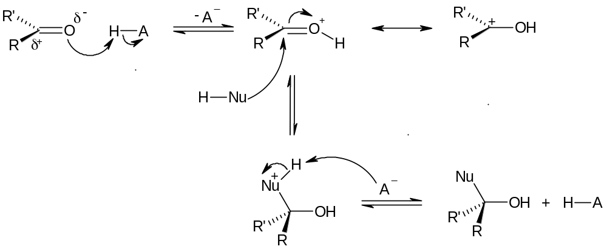

Floor F of the Pyramid:
By combination of 20 (in real 22) proteinogenous aminoacids all known proteins are formed.

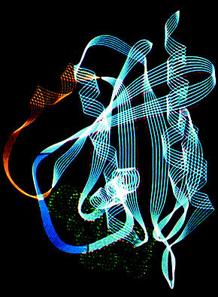
3D struktura proteinu je dána jeho terciární strukturou. Výsledné prostorové uspořádání proteinu je závislé na pořadí jednotlivých aminokyselin v řetězci. Různé aminokyseliny mají různé biochemické vlastnosti a tak jejich kombinace a kombinace jejich vlastností udává jak prostorové záhyby aminokyselinového řetězce, z nichž je „stvořena“ konečná podoba proteinu, tak i konečné vlastnosti proteinů
V proteinech jsou aminokyseliny vzájemně vázány aminoskupinami –NH₂ a karboxylovými skupinami –COOH amidovou vazbou –NH–CO– (amidy), která se v případě proteinů nazývá peptidová vazba.
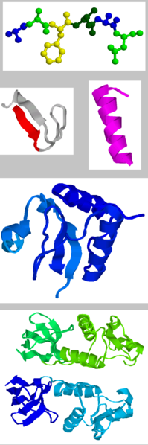

Proteinogenous aminoacids
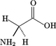
Glycine (Gly, G)
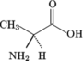
Alanine (Ala, A)
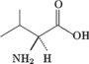
Valine (Val, V)
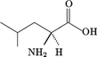
Leucine (Leu, L)
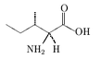
Isoleucine (Ile, I)
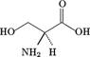
Serine (Ser, S)
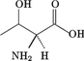
Threonine (Thr, T)
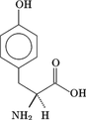
Tyrosine (Tyr, Y)
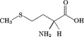
Methionine (Met, M)
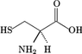
Cysteine (Cys, C)
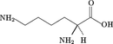
Lysine (Lys, K)
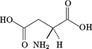
Kyselina asparagová (Asp, D)
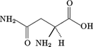

Kombinací 20 (ve skutečnosti 22) proteinogenních aminokyselin jsou tvořeny všechny známé bílkoviny.Asparagin (Asn, N)
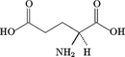
Kyselina glutamová (Glu, E)
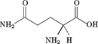
Glutamin (Gln, Q)
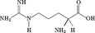
Arginin (Arg, R)
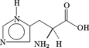
Histidin (His, H)
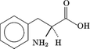
Fenylalanin (Phe, F)
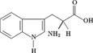
Tryptofan (Trp, W)
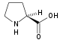
Prolin (Pro, P)
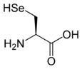
Selenocystein (SeCys,U)
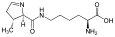
Pyrolysin (Pyl,O)

http://cs.wikipedia.org/wiki/B%C3%ADlkovina

Floor G of the Pyramid:
This is the world of proteins, DNA and interaction between biopolymers of all different kinds.

Bílkoviny, odborně proteiny, patří mezi biopolymery. Jedná se o vysokomolekulární přírodní látky s relativní molekulární hmotností 10³ až 10⁶ složené z aminokyselin.

Základní stavební částicí bílkovin jsou aminokyseliny, a tak je zřejmé, že se bez nich tzv. proteosyntéza neobejde. Některé aminokyseliny je schopné tělo vyrábět samo, jiné musí přijímat v potravě (k těmto tzv. esenciálním aminokyselinám patří u člověka v dospělosti 12 aminokyselin, v dětství 14^{[2]}). Bílkoviny jsou ve většině případů kódovány v specifických úsecích v DNA organismů. Tyto úseky (tzv. geny) jsou přepisovány v procesu transkripce do mRNA a na ribozomu následně dochází k výrobě proteinů (translaci) za účasti této mRNA a jednotlivých aminokyselin napojených na specifické tRNA.
Zvláštností jsou bílkoviny, které jsou kódovány v genomu a přepisovány do mRNA, nicméně nevznikají na ribozomu, nýbrž na speciálních rozpustných enzymech v cytoplazmě, jež jsou schopné mRNA číst podobně, jako ribozom. Říkáme jim neribozomální peptidy, protože obvykle nedosahují takové délky jako skutečné bílkoviny. Patří k nim některá polypeptidová antibiotika. Jejich produkce zůstane zachována i tehdy, zablokujeme-li ribozomální mašinérii. K těmto polypeptidům patří chloramfenikol a graminicin S. Mechanismus syntézy těchto antibiotik je trochu podobný syntéze mastných kyselin.^{[3]}
……………….
It is important to mention that on every floor of the pyramid muman intelligence had use different „recording technique“ in order to uderpin view of complexity of the nature.... which begun as the“curving“of dimensions as the „motive“ to mass elements and even conglomerates of them to be built up from dimensions of the two basic quantities.

16.06.2012
**************************************************************************.

Conclusion: It’s beautiful and enhancing to understand the mentioned pyramid above and imagine it as the seven-floor building that bears name SCIENCE and where there is different recording technique on each of the floor for decription of the Nature → different technique for particle and atomic physics, for chemistry, for biology etc. in each of the faculties there is different recording technique of how to describe Nature.They are always an abstract choices of how nature can be described. I have elaborated also my own recording technique for „single-block interaction“ and am convinced of it to be also beautiful, senseful and applicable...
It would be fair if eventually somebody will come to see my hypothesis and start to deal with it seriously. It was my effort and struggling which took about 32 years and I think that my alternative recording technique is unique : http://www.hypothesis-of-universe.com/index.php?nav=e . It would be very fair to consider impartially vision of the two-quantity universe.

Completed
JN, 01.03.2014 + 04.03.2014
+ 14.12.2014 → https://www.youtube.com/watch?v=g2Uh7OnI85E This is gorgeous demonstration for abstract intellectual imagination of how evolution of the matter and the natural laws in the universe could be expressed since the Big-Bang until present days. For whom with excellent visualization must be understable enough that „domino effect“ presented on this you-tube compared with real evolution of the matter and growing up its complexity is just very pure and imperfect example. We have to admit that nature itself creates mass structures and related laws to them according to inconceivable recipe. Human being can’t imagine this process because he is limited.

^{Translated 2015}

